Steps:

1. I downloaded the latest version of jGrasp—the one that comes bundled with several programs
2. I downloaded a copy of the javafx-sdk-11.0.2 and unzipped it to my c:\ drive
3. Under settings within jGrasp
   1. Select Compiler Settings and click on Workspace.
   2. Click on the JavaFX tab and add the following information as shown in the diagram

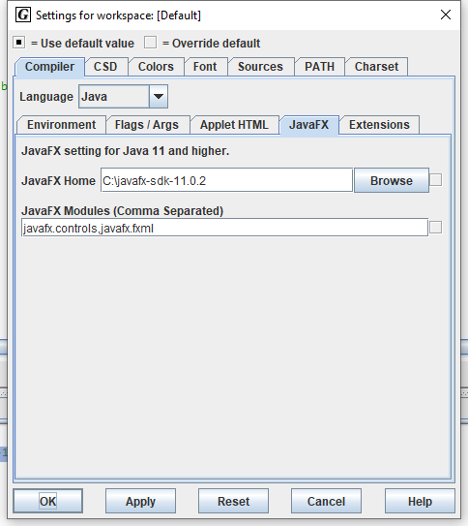

When the JavaFx application file is executed jGrasp places the following information in the run I/O tab box and runs the GUI—see it below.

----jGRASP exec: java --module-path C:\javafx-sdk-11.0.2\lib --add-modules=javafx.controls,javafx.fxml bagelEx4  
  
----jGRASP: operation complete.

